Computer Network

Homework #4 for Chapter 6

19102100 Choi Jiwoo

Chapter 6

P7. In this problem, we explore some of the properties of the CRC. For the generator G(=1001) given in Section 6.2.3, answer the following questions.

1. Why can it detect any single bit error in data D?
   1. When single bit error occurs, data D divided by G should produce remainder of 0. If it’s not, then it means that there’s a single bit error.
2. Can the above G detect any odd number of bit errors? Why?
   1. Any data which has odd-number of 1’s cannot be divided by 11, however, G1001 cannot be divided by 11. Thus, even if there’s no bit errors in the data, it may result in producing remainder of nonzero.

P8. In Section 6.3, we provided an outline of the derivation of the efficiency of slotted ALOHA. In this problem we’ll complete the derivation.

1. Recall that when there are N active nodes, the efficiency of slotted ALOHA is Np(1−p)N−1. Find the value of p that maximizes this expression.
   1. 텍스트, 친필, 폰트, 서예이(가) 표시된 사진

      자동 생성된 설명
2. Using the value of p found in (a), find the efficiency of slotted ALOHA by letting N approach infinity. Hint: approaches 1/e as N approaches infinity.
   1. 텍스트, 친필, 폰트, 서예이(가) 표시된 사진

      자동 생성된 설명

P11. Suppose four active nodes—nodes A, B, C and D—are competing for access to a channel using slotted ALOHA. Assume each node has an infinite number of packets to send. Each node attempts to transmit in each slot with probability p. The first slot is numbered slot 1, the second slot is numbered slot 2, and so on.

1. What is the probability that node A succeeds for the first time in slot 5?

1. What is the probability that some node (either A, B, C or D) succeeds in slot 4?

Since each events are mutually exclusive, the probability becomes multiplied by 4.

1. What is the probability that the first success occurs in slot 3?
2. What is the efficiency of this four-node system?

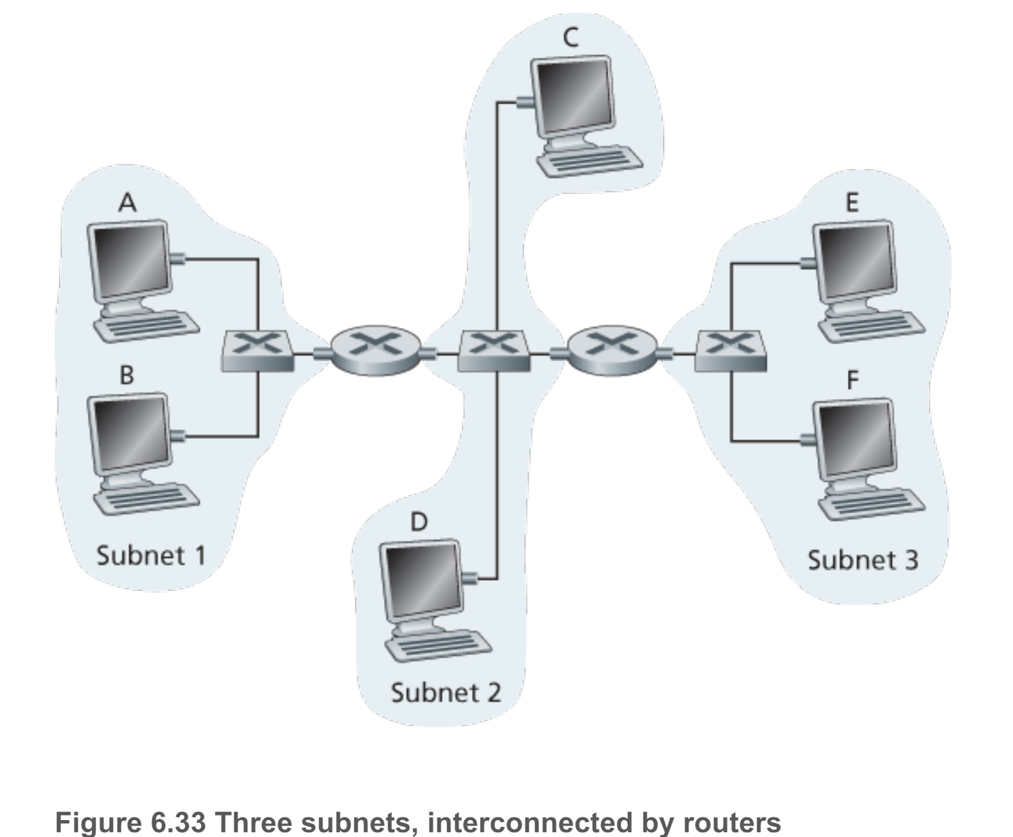

P14. Consider three LANs interconnected by two routers, as shown in Figure 6.33.

1. Assign IP addresses to all of the interfaces. For Subnet 1 use addresses of the form 192.168.1.xxx; for Subnet 2 uses addresses of the form 192.168.2.xxx; and for Subnet 3 use addresses of the form 192.168.3.xxx.
   1. 192.168.1.1
   2. 192.168.1.3

(Router1 Interface at Subnet 1) : 192.168.1.2

* 1. 192.168.2.1
  2. 192.168.2.4

(Router1 Interface at Subnet 2) : 192.168.2.2

(Router2 Interface at Subnet 2) : 192.168.2.3

* 1. 192.168.3.1
  2. 192.168.3.3

(Router2 Interface at Subnet 3) : 192.168.3.2

1. Assign MAC addresses to all of the adapters.
   1. 00-00-00-00-00-00
   2. 11-11-11-11-11-11

(Router1 Interface at Subnet 1) : 22-22-22-22-22-22

* 1. 44-44-44-44-44-44
  2. 66-66-66-66-66-66

(Router1 Interface at Subnet 2) : 33-33-33-33-33-33

(Router2 Interface at Subnet 2) : 55-55-55-55-55-55

* 1. 77-77-77-77-77-77
  2. 88-88-88-88-88-88

(Router2 Interface at Subnet 3) : 192.168.3.2

1. Consider sending an IP datagram from Host E to Host B. Suppose all of the ARP tables are up to date. Enumerate all the steps, as done for the single-router example in Section 6.4.1.
   * 1. Make a datagram that includes IP address of Router 2 by searching forwarding table of it.
     2. Host E generates ethernet frame which includes the header of the datagram and MAC address of Router 2
     3. Router 2 receives the packed and extract the datagram. Then the forwarding table determines next route (Router 1)
     4. Router 2 generates new Ethernet frame which includes destination MAC address (MAC address of Router 1)
     5. Router 1 extracts the frame and get the address of destination which is Host B. Then the router sends the datagram to the destination.
2. Repeat (c), now assuming that the ARP table in the sending host is empty (and the other tables are up to date)
   1. ARP table in Host E must determine the MAC address of Router 2. If the host does not know the MAC address, then it can sends ARP query packet to Router 2. If the router receives the query packet, then it sends back with packet which includes the MAC address of itself. After that, Host E now get to know the mac address of Router 2 and updates its ARP table with the address.



P15. Consider Figure 6.33 . Now we replace the router between subnets 1 and 2 with a switch S1, and label the router between subnets 2 and 3 as R1.

1. Consider sending an IP datagram from Host E to Host F. Will Host E ask router R1 to help forward the datagram? Why? In the Ethernet frame containing the IP datagram, what are the source and destination IP and MAC addresses?
   1. No. E can get to know that Host F is in the same local network by checking the subnet prefix of Host F’s IP address.
   2. Source IP address : E’s IP address

Destination IP address : F’s IP address

Source MAC address : E’s MAC address

Destination MAC address : F’s MAC address.

1. Suppose E would like to send an IP datagram to B, and assume that E’s ARP cache does not contain B’s MAC address. Will E perform an ARP query to find B’s MAC poll address? Why? In the Ethernet frame (containing the IP datagram destined to B) that is delivered to router R1, what are the source and destination IP and MAC addresses?
   1. No. they are not on the same local network.
   2. Source IP address : E’s IP address

Destination IP address : Bs IP address

Source MAC address : E’s MAC address

Destination MAC address : The MAC address of R1’s interface connecting to subnet 3.

1. Suppose Host A would like to send an IP datagram to Host B, and neither A’s ARP cache contains B’s MAC address nor does B’s ARP cache contain A’s MAC address. Further suppose that the switch S1’s forwarding table contains entries for Host B and router R1 only. Thus, A will broadcast an ARP request message. What actions will switch S1 perform once it receives the ARP request message?

S1 will broadcast the ARP request message to every port in it. Now S1 get to know that A is included in S1 so it will update its forwarding table to include Host A.

Will router R1 also receive this ARP request message? If so, will R1 forward the message to Subnet 3?

Yes. router R1 also receives this ARP request message, however, it won’t forward the message to Subnet 3.

Once Host B receives this ARP request message, it will send back to Host A an ARP response message. But will it send an ARP query message to ask for A’s MAC address? Why?

What will switch S1 do once it receives an ARP response message from Host B?

As Host B receives the ARP request message from A, it now know the MAC address of A. So it won’t send an ARP query message. S1 will update its forwarding table to add an entry for host B because it already received ARP response message from host B. After that, S1 will check the destination address of ARP response (=MAC address of Host A), and then it will drop the received frame sine host A and B are on the same local network.



|  |  |  |
| --- | --- | --- |
| Name | MAC address | IP address |
| Host A | 00-00-00-00-00-00 | 111.111.111.001 |
| Router R1 (interface 1) | 11-11-11-11-11-11 | 111.111.111.002 |
| Router R1 (interface 2) | 33-33-33-33-33-33 | 122.222.222.002 |
| Router R2 (interface 1) | 55-55-55-55-55-55 | 122.222.222.003 |
| Router R2 (interface 2) | 88-88-88-88-88-88 | 133.333.333.002 |
| Host F | 99-99-99-99-99-99 | 133.333.333.003 |

P21. Consider Figure 6.33 in problem P14. (1) Provide MAC addresses and IP addresses for the interfaces at Host A, both routers, and Host F. Suppose Host A sends a datagram to Host F. (2) Give the source and destination MAC addresses in the frame encapsulating this IP datagram as the frame is transmitted

(1)

(2)

(i) from A to the left router

|  |  |
| --- | --- |
| Name | Address |
| Source IP address | 111.111.111.001 |
| Destination IP address | 133.333.333.003 |
| Source MAC address | 00-00-00-00-00-00 |
| Destination MAC address | 11-11-11-11-11-11 |

1. from the left router to the right router

|  |  |
| --- | --- |
| Name | Address |
| Source IP address | 111.111.111.001 |
| Destination IP address | 133.333.333.003 |
| Source MAC address | 33-33-33-33-33-33 |
| Destination MAC address | 55-55-55-55-55-55 |

1. from the right router to F.

|  |  |
| --- | --- |
| Name | Address |
| Source IP address | 111.111.111.001 |
| Destination IP address | 133.333.333.003 |
| Source MAC address | 88-88-88-88-88-88 |
| Destination MAC address | 99-99-99-99-99-99 |

P26. Let’s consider the operation of a learning switch in the context of a network in which 6 nodes labeled A through F are star connected into an Ethernet switch. Suppose that

1. B sends a frame to E
2. E replies with a frame to B
3. A sends a frame to B
4. B replies with a frame to A.

The switch table is initially empty. Show the state of the switch table before and after each of these events. For each of these events, identify the link(s) on which the transmitted frame will be forwarded, and briefly justify your answers.

* Initially, the switch table is empty.

1. B sends a frame to E

Switch learns MAC address of B.

Since there’s no address for destination address in switch table(=MAC address of E) the switch will broadcast it to every nodes except B. Furthermore, the switch does not know the MAC address of E

1. E replies with a frame to B

Switch learns the MAC address of E. In this case, switch table already know the interface corresponding to MAC address of B, so the broadcast will be forwarded just to B.

(iii) A sends a frame to B

Switch learns the interface corresponding to MAC address of A. Same case for ii, the table knows the MAC address of B, so it just broadcast to B

(iv) B replies with a frame to A.

Since switch table has addresses of A and B, no update will be taken. The broadcast will be forwarded to A